Interceptor Bidding Process Analysis
Yeqi Sang
- Problem Currently Addressed by the Code
The current interceptor bidding process addresses a prediction-driven interceptor recall and assignment problem. When an active tracker predicts that it will lose a target, the system triggers a handover call and selects new interceptor sensors to move toward a predicted intercept point before the original tracker loses coverage.
- For each calling target, the code gathers all eligible candidate sensors.
- Each candidate computes a bid cost, where a lower cost indicates a more suitable interceptor for that target.
- If only one target is calling, the code selects the two lowest-cost interceptors.
- If two targets call at the same time and their best two-sensor teams overlap, the code runs an additional conflict-resolution step to produce a non-overlapping 2-plus-2 assignment.
Therefore, the implemented logic is best viewed as a heuristic interceptor selection mechanism for single-target assignment and a partial conflict-resolution mechanism for the two-target case.
2. Target Research Problem
The broader research problem is a global resource-allocation problem with competing targets and limited interceptor resources.
- There are k targets that may simultaneously request interceptor support.
- Each target can be assigned at most m interceptors.
- A pool of idle or reassignable(returning) sensors is available as interceptor candidates.
- Each candidate sensor has a target-dependent assignment cost.
- The system should maintain unique assignment, so one interceptor cannot be assigned to multiple targets at the same time.
- The system should assign as many interceptors as possible, ideally up to m per target, and only leave a target under-served when the candidate pool is insufficient.
- After maximizing feasible coverage, the overall assignment cost should be minimized.
A natural development path is to first optimize the special case k = 2 and m = 2, and then generalize the formulation to arbitrary k and m.

3. Mathematical Form of the Current Method
Let T = {1, ..., k} denote the set of calling targets, and let S = {1, ..., n} denote the set of eligible interceptor candidates. Let $c(i, j)$ be the bid cost of assigning sensor i to target j.
In the current code, the bid is a weighted sum:
$$c(i,j) = w_{1} P_home(i) + w_{2} P_spatial(i,j) +w_{3} P_temporal(i,j) + w_{4} P_uncertainty(i,j)$$
- $P_home$ penalizes the displacement of a sensor from its home location.
- $P_spatial$ penalizes the distance from the sensor to the target intercept point.
- $P_temporal$ penalizes poor arrival timing relative to the target motion.
- $P_uncertainty$ penalizes low shared confidence in the target estimate.
For two simultaneous targets, the code applies a repair-based strategy:
- First, it independently computes the best two-sensor team for each target.
- Second, it checks whether the selected teams overlap.
- If overlap exists, it performs a minimax-style enumeration over a reduced candidate subset and selects the non-overlapping assignment that minimizes the worst team cost.
This means the current approach does not solve one unified global optimization problem. Instead, it first obtains local optima and then repairs conflicts when necessary.
4. Why the Current Method is Sub-optimal
- It is not a single globally optimized formulation.
- It may miss better global assignments because it starts from per-target local minima.
- Its objective changes across cases: single-target selection minimizes additive cost, while conflict repair for two targets uses a minimax criterion.
- It does not rigorously encode the priority of maximizing assignment coverage before minimizing cost.
- When the candidate pool is insufficient, it does not provide a clean and systematic partial-allocation rule.
Its main strengths are simplicity, low computational burden, and easy integration into the current monolithic MATLAB simulation. Therefore, it is best described as a practical conflict-aware heuristic rather than a globally optimal multi-target allocation algorithm.

5. More Efficient and More Optimal Alternatives
A more systematic solution is to formulate the interceptor assignment as a global constrained optimization problem.
Let $x\left(i, j\right)$ represents if sensor i is triggered by target j, then we can have:
$$x\left(i,j\right)= \left\{\begin{aligned}1, if sensor is assigned to target j \\ 0, otherwise\end{aligned}\right.$$
$$\sum_{j}^{T}{x\left(i,j\right)}≤1, for all sensors i$$
$$\sum_{i}^{S}{x(i,j)}≤m, for all targets j$$
The objective is:
- Maximize the total number of assigned interceptor slots.
- Among all maximum-coverage assignments, minimize the total assignment cost
Equivalently, one may introduce shortage variables $u\left(j\right)=m- \sum_{i}^{S}{x(i,j)}$ and minimize shortage before minimizing cost. This directly captures the requirements that each target should receive as many interceptors as possible and only be under-served when the candidate pool is insufficient.

Two strong algorithmic options follow from this formulation.
- Min-cost max-flow: Duplicate each target into m targets slots, connect each sensor to eligible slots with edge cost $c(i,j)$ and solve a global min-cost max-flow problem. This gives an exact and computationally efficient solution for the small-medium-size instances relevant to the simulation configuration.
- MILP: Use binary decision variables and solve the allocation as mixed-integer linear program. This is clean to present mathematically and yields a global optimum at the current problem scale. (Only for future development)

6. Method: Min-cost Max-flow
Problem Formulation Refine:
The generalized interceptor allocation problem can be written as:
$$min\sum_{i∈S}{\sum_{j∈T}{c\left(i,j\right)x(i, j)}}$$
Subject to
$$\sum_{j∈T}{x\left(i,j\right)}≤1, ∀ i∈S$$
$$\sum_{i∈S}{x(i,j)}≤m, ∀ j∈T$$
$$x\left(i,j\right)∈\left\{0, 1\right\}, ∀ i∈S, ∀ j∈T$$

To prioritize coverage before cost minimization, a lexicographic objective can be used:
  - Maximize the total number of assigned interceptor slots
  - Among all maximum -coverage assignments, minimize the total assignment cost
This can be written using shortage variables. Define
$$u_{j}=m-\sum_{i∈S}{x\left(i,j\right)}, u_{j}≥0$$
Then the optimization can be stated into two stages:
Stage 1: Minimize total shortage
$$\min_{x(i, j)}\sum_{j∈T}{u_{j}}$$
Stage 2: Minimize cost among all minimum-shortage solutions
$$min\sum_{i∈S}{\sum_{j∈T}{c\left(i,j\right)x(i, j)}}$$
This formulation directly reflects the practical requirement that each target should receive as many interceptors as possible, and that cost minimization should be considered only after coverage is maximized.

Min-cost Max-Flow Formulation
The interceptor allocation problem can be represented as a layered flow network. The key idea is to expand each target into m identical interceptor slots. Instead of assigning sensors directly to targets, the algorithm assigns each sensor to one target-slot node.
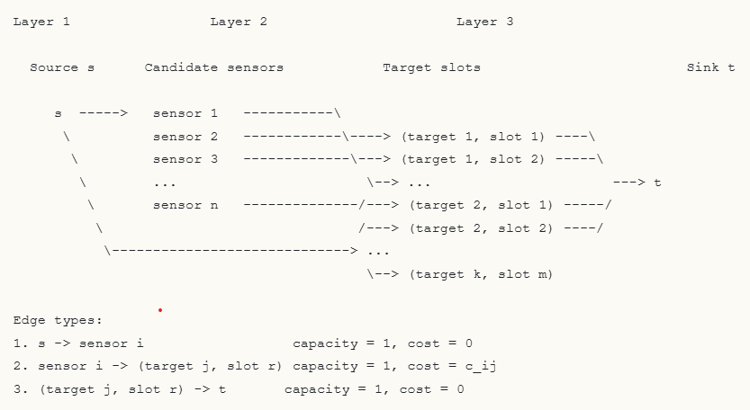
To solve the problem as a min-cost max-flow problem, each target j is expanded into m target-slot nodes:
$$\left(j, 1\right), \left(j, 2\right), …, (j, m)$$
A directed flow network is then constructed as follows:
- Add a source node s
- Add one node for each sensor $i∈S$
- Add one node for each target slot $(j, r)$ where $j∈T$ and $r=1, …, m$
- Add a sink node t
Edge construction:
- source-to-senor edges: (s, i), capacity = 1, cost = 0
- sensor-to-slot edges: (i, (j, r)), capacity = 1, cost = $c(i, j)$, for every feasible $pair(i, j)$ and every slot $r=1, …, m$
- slot-to-sink edges: ((j, r), t), capacity = 1, cost = 0
The optimization object is:
- maximize the total flow from s to t
- while minimizing the total cost of the flow
A unit of flow represents that a sensor is assigned to target $j$ at slot $r$, where $r=1,…,m$, indicating the $r$-th interceptor position of that target.
Here is a simple example.
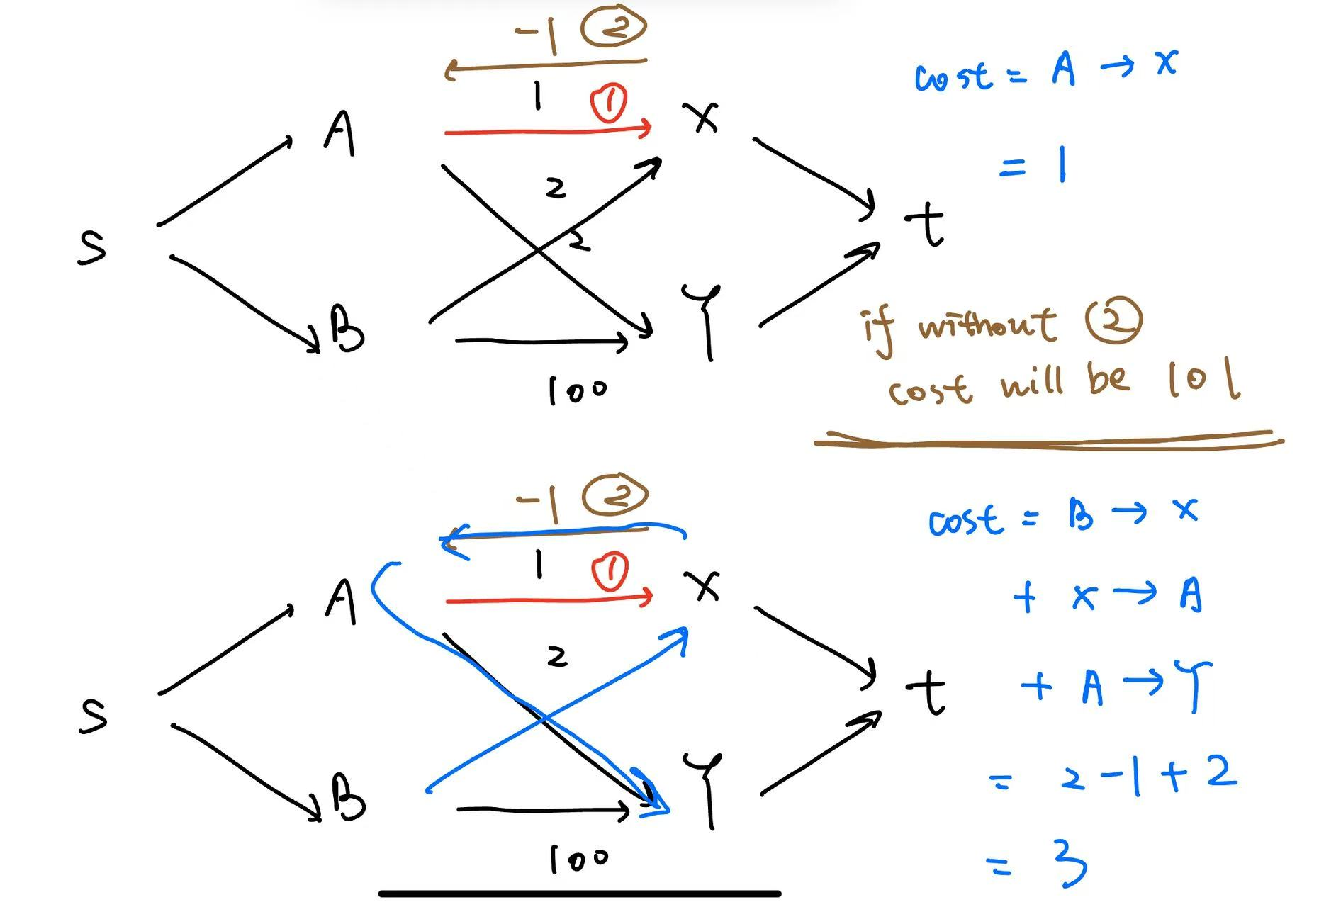
We have edges $(A, X)$ with cost 1, $(A, Y)$ with cost 2, $(B, X)$ with cost 2, and $(B, Y)$ with cost 100, while all other edges have zero cost. In the first iteration, the minimum-cost path is $s→A→X→t$, so sensor $A$ is assigned to slot $X$. The residual graph is then updated, and a reverse edge $\left(X , A\right)$ is introduced to allow this assignment to be revised if needed. In the second iteration, the algorithm finds a new augmenting path that effectively cancels $A→X$, assigns $B→X$, and reassigns $A→Y$. The final allocation becomes $B→X$ and $A→Y$, with total cost 4, which is much lower than the greedy solution cost of 101.
In general, the interceptor allocation problem is solved as a min-cost max-flow problem on the constructed graph. At each iteration, the algorithm finds the current minimum-cost feasible augmenting path, sends one unit of flow, and updates the residual graph. Reverse edges allow previously selected assignments to be revised if a lower-cost global allocation becomes possible. The procedure continues until no further feasible augmenting path exists. At that point, the current flow gives the maximum achievable target-slot coverage, and the final sensor-to-slot edges carrying unit flow define the globally optimal interceptor assignment under the stated objective.

Time Complexity:
The number of target slots is at most $km$, and each iteration assigns at most one additional slot. Since the graph contains $O(nkm)$ edges and at most $min⁡(n,km)$ augmentations are required, the overall runtime remains polynomial and small for the present problem size.
This makes the method suitable for online use in the present project because the problem scale is very limited. In the current WSN setting, there are at most 25 sensors, at most 3 targets, and at most 2 interceptor slots per target, so the total number of target slots never exceeds 6. This means that each reallocation event only requires solving a very small flow problem. Therefore, the optimization can be completed quickly enough to support real-time or near-real-time interceptor assignment during simulation, and potentially in practical robotic implementations of similar scale

Next Steps
- Conduct further analysis of the computational complexity and define appropriate metrics for evaluating online feasibility.
- Further investigate the limitation of standard min-cost max-flow in this problem. It maximizes total slot coverage but does not guarantee balanced per-target coverage. In resource-limited cases, this may lead to one target receiving multiple interceptors while another remains under-served. Therefore, a possible next step is to design a hierarchical allocation policy, for example, by first ensuring baseline target coverage and then applying min-cost max-flow to optimize the remaining assignments.

